Order Of Service

Singing: Psalm 24—CW page 73

Reading: Psalm 133

Opening Hymn: CW 256

Reading: Romans 13:8-14

Request Hymn: CW Supplement 750

Reading: Matthew 22:34-40

Sermon Hymn: CW 370

Sermon Text: Luke 4:33-37

An Unclean Spirit

Prayer

The Apostles’ Creed, TLH page 12

Holy Communion

The Lord's Prayer

The Blessing

Closing Hymn: CW 327

* * * * * * * * * * *

Koinonia Hour

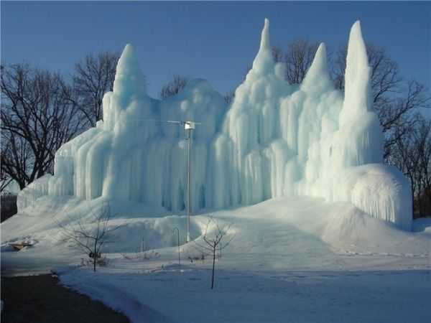

Winter In Duluth, MN

Water
Of
Life

7 February 2021

W A T E R O F L I F E

Independent Christian Church—Conservative Lutheran Doctrine

Worship Service: 9:30 a.m. Bible Study: 10:45 a.m.

Larry Cooper, Pastor E-Mail address:
111 N. Ridge Road lcooper@wateroflife.cc
Coon Valley, WI 54623 Web Site:
www.wateroflife.cc

* * * * * * * * * * * * * * * * * * * * * * * * * * *

Sermon Text: Luke 4:33-37

An Unclean Spirit

* * * * * * * * * * * * * * * * * * * * * * * * * * *

Luke 4:33 And in the synagogue there was a man, which had a spirit of an unclean devil, and cried out with a loud voice,
:34 Saying, Let us alone; what have we to do with thee, thou Jesus of Nazareth? art thou come to destroy us? I know thee who thou art; the Holy One of God.
:35 And Jesus rebuked him, saying, Hold thy peace, and come out of him. And when the devil had thrown him in the midst, he came out of him, and hurt him not.
:36 And they were all amazed, and spake among themselves, saying, What a word is this! for with authority and power he commandeth the unclean spirits, and they come out.
:37 And the fame of him went out into every place of the country round about.

